**Analysis Topic 10**

**System Analysis & Design & CIS-2245**

|  |  |
| --- | --- |
| Author: | **Christopher Sigouin** |
| Date: | November 21, 2015 |
| Due Date: | November 23, 2015 |
| Assignment: | Analysis Topic 10 |
|  |  |
|  |  |
| Mark: | __________ |

Questions for your respective case study are:

* Based on the information provided create a Storyboard interface design for your system.  It should include at your 'MAIN' interface and 3 other key interfaces of your system.
* Consider security/access controls in your interface design.
* Your design should be created in either Visio (interface design) or .NET IDE.

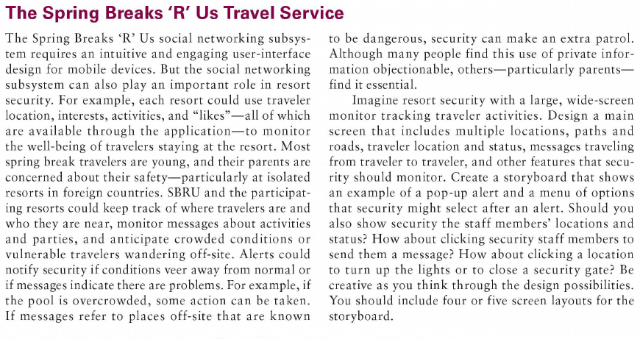

INTERFACES ( Main and 3 others )

Resort Security tracking traveler activities

Main

Multiple Locations

Paths

Roads

Traveler Location and Status

Messages traveling from traveler to traveler

etc…

Example of a pop up alert and menu options that security might select after an alert

Show security staff members location and statuses?

Clicking staff members to send a message

Clicking a location to turn up the lights or close security gate

Be creative

Main Security Interface,